Section 1 –
Introduction
PESTLE analysis
Section 2 – (this has the most points)
Applying IDIC framework to Fferal clothing
Section 3
Customer service Metrics analysis

Organisations use a number of metrics to evaluate the success of their customer service. Most commonly used metrics are:

Net Promoter score (NPS)
Customer Acquisition cost (CAC)
Customer Lifetime Value (CLV)
CAC-to-CLV
Customer satisfaction score (CSAT)
Customer effort score (CES)
Customer Retention rate
Revenue Churn
First contact resolution
Average ticket time 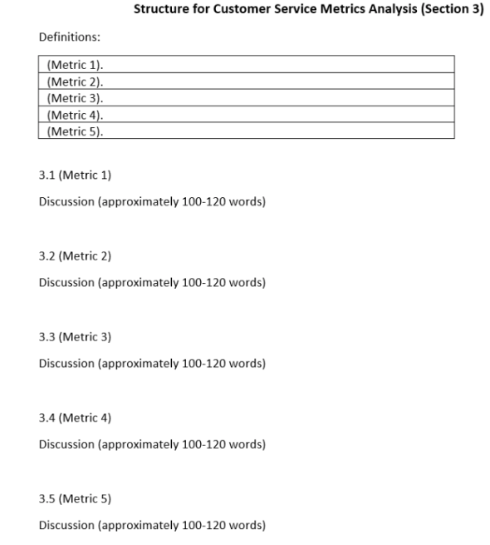

Metrics definitions (something is not counted with this part for word counts check the brief)

- This section is a mini literature review
- Have you identified and defined five customer service metrics?
- Discussion for each metric should be well-developed showing critical thinking skills
- Discussion should be supported well with credible academic and practitioner literature
- Section 4 –
Recommendations : this section should be built upon the sections 1 to 3. By integrating the case study with knowledge acquired from your research, you are expected to offer recommendations to Fferal clothing. Your recommendation should be in relation to how Fferal clothing can improve its customer relationships. In this section, we expect to see frequent refrences to the case study and the literature support your argument.

